City of Woodburn

Memo
To: | Chris Kerr – City of Woodburn Development Director
From: | Jesse Cuomo – City of Woodburn Community Services Director
cc: | Jeff Crabtree – City of Woodburn Parks and Facility Maintenance Manager  CPSI Certified
Date: | 1/17/24
Re: | Dove Landing Playground Safety Audit and Park Amenity Walk
Inspection:
City of Woodburn Certified Playground Safety Inspector (CPSI) Jeff Crabtree conducted the playground safety audit of the play structures and surfacing at Dove Landing on 1/11/24.
Findings:
Here are the noted aspects that we believe are non-compliant with ASTM standards for Public Playgrounds.
- 3 head entrapment hazards were identified. (view video links below)

  - The top and bottom opening built into the Tic Tac Toe activity wall has gaps in it that allow the torso probe to pass but not the head probe.
  - A barrier wall opposite the activity wall also has a gap between the bottom of the barrier wall and the play platform. Again, the torso probe fits through, but the head probe does not. If the torso fits, then the head probe must fit as well.
- The rock-climbing wall is attached to the composite play structure. (photos below)

  - Mismatched bolts that have all been cut shorter with a cut off wheel. These cuts were left with sharp edges or burs. These bolts are also already rusting. The fact that they are mismatched and had to be cut shorter indicates that the bolts that came with the structure may not have been used.
` 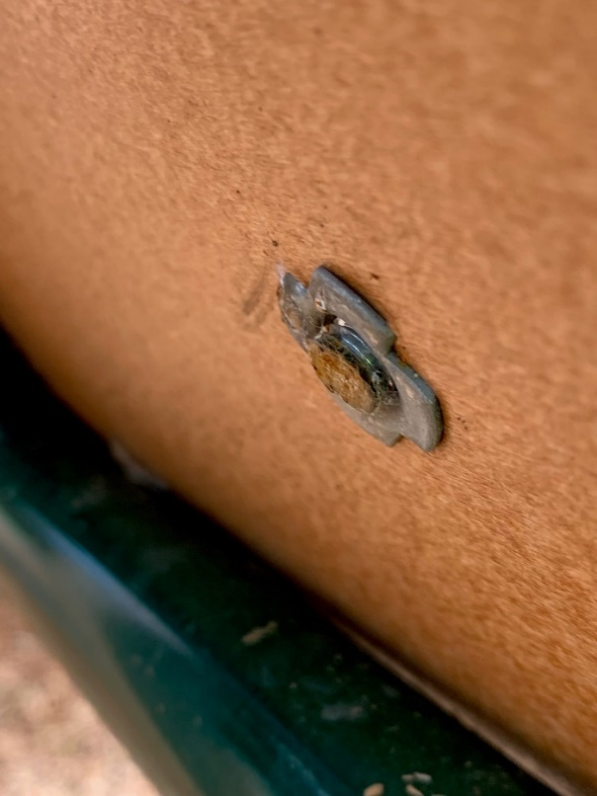 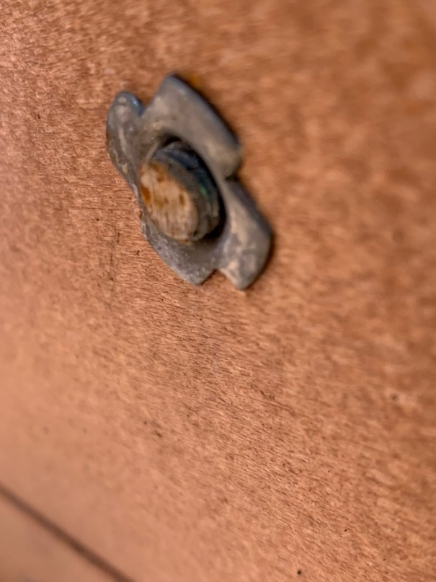
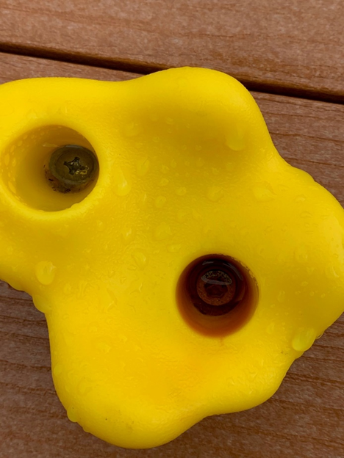
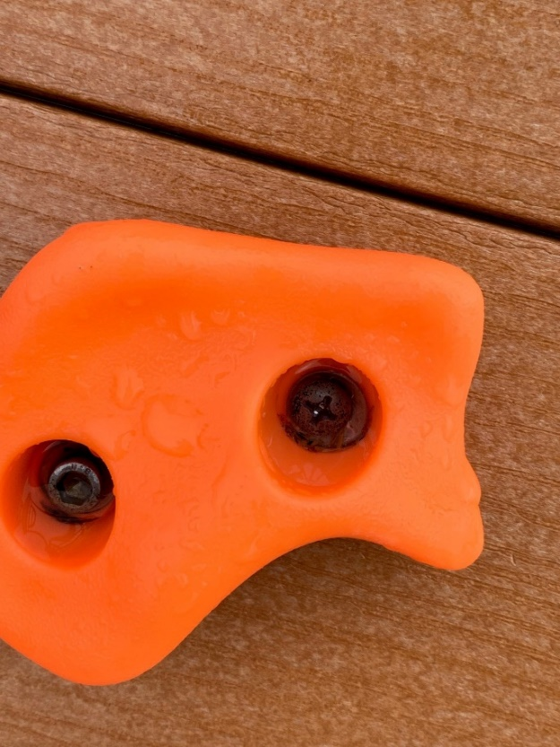

- The slide oriented from West to East has a slight wobble, even before it has been played on. (see photos below)

  - The slide appears to have been designed to have a second support leg. I assume that is because the slide has a slight curve, and that second leg would be underneath the slide where it curves slightly.
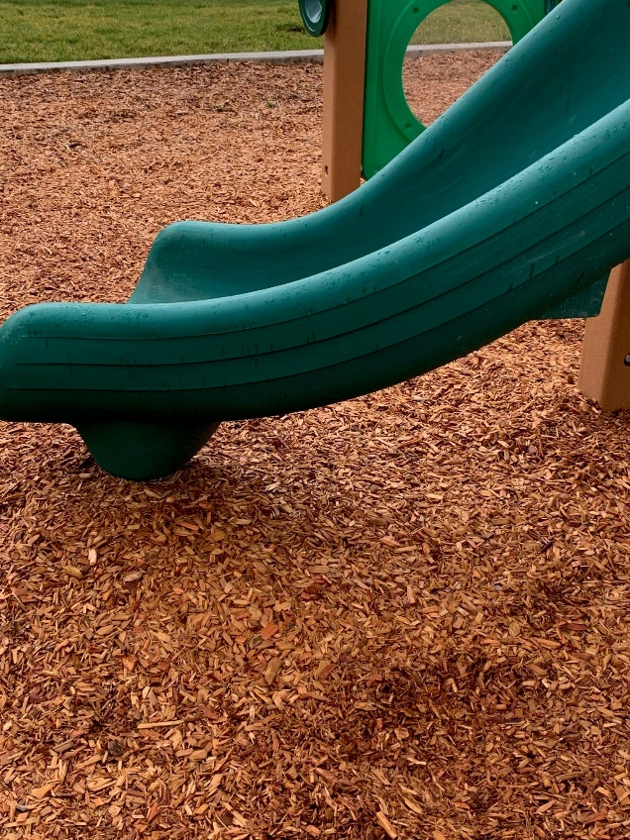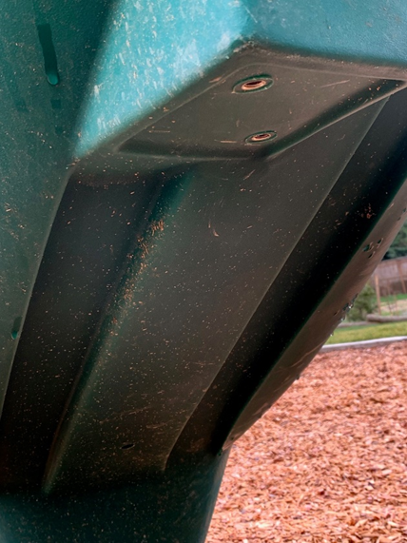

- The steering wheel built into the composite structure is loose and wobbles significantly. (see photos and video below)

  - It is loose enough that my 1/8-inch gauge can fit between the post and the steering wheel. This could feasibly crush the finger on a small child. I do not know if a part is missing; or the wheel is just not tightened enough to remove the gap that is left.
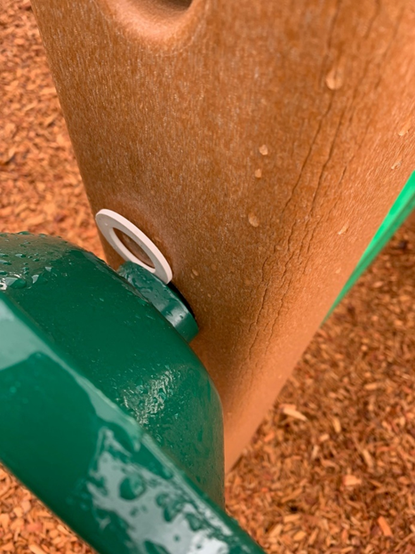

- Engineered Wood Fiber and Safety Surfacing (see photos below)

  - Overall, the average depth of the engineered wood fiber appears to be 7 inches of uncompressed material.

    - CPSI Requirement - 6 inches of uncompressed engineered wood fiber have a critical fall height protection of 6 feet (72 inches).

    - CPSI Requirement - 9 inches of uncompressed engineered wood fiber would have critical fall height protection of 7 feet (84 inches).

    - CPSI Requirement - 12 inches of uncompressed engineered wood fiber would have critical fall height protection of greater then 12 feet (144 inches).

  - Safety Surfacing Deficiencies

    - The larger arch rock-climbing structure has a critical fall height of 72 inches.

    - The tallest swings have a critical fall height of 96 inches.

    - The climbing feature on the Southside of the composite climbing structure has a critical fall height of 118 inches.

    - The climbing feature actually gives a child access to the roof structure, so the height would actually be even higher than that. To meet critical fall height protection engineered wood fiber needs to be added to the play area.
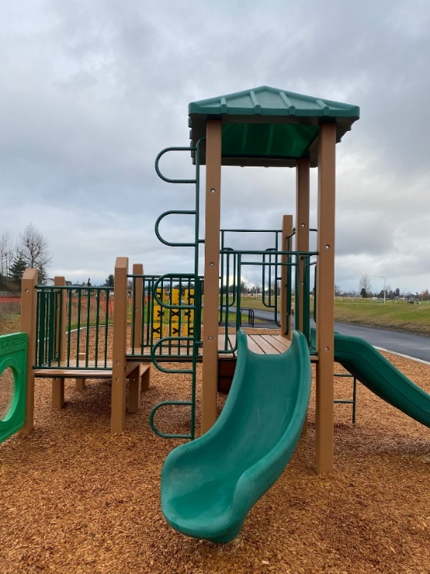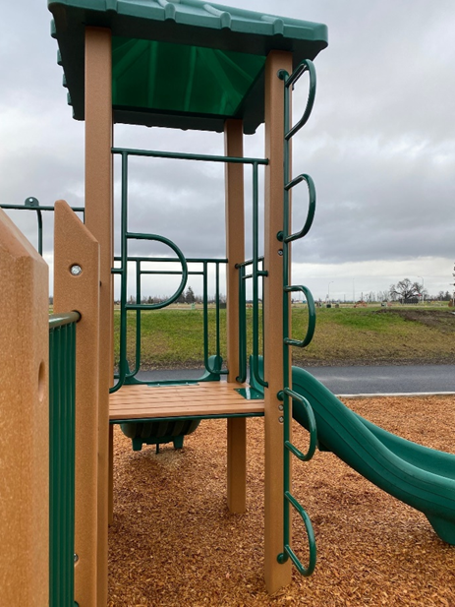
- Play structure has open holes on the underside of the slides and roof. (see photos below)

  - These may serve a purpose for air movement and drainage, but they are also perfect holes for wasps and/or yellow jackets to make a nest. As well as kids stilling fingers and debris in these holes. I do not know if the ATSM standards address this issue but seems worthy of noting.
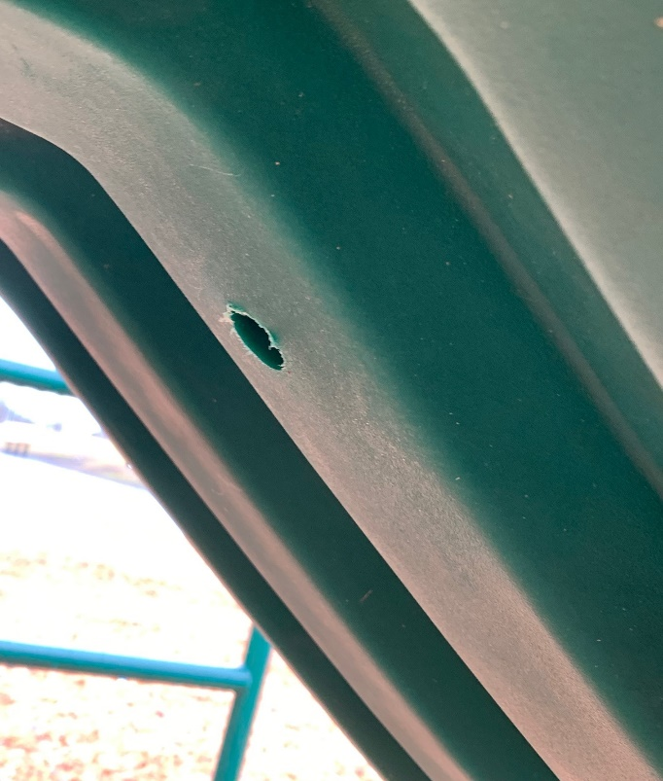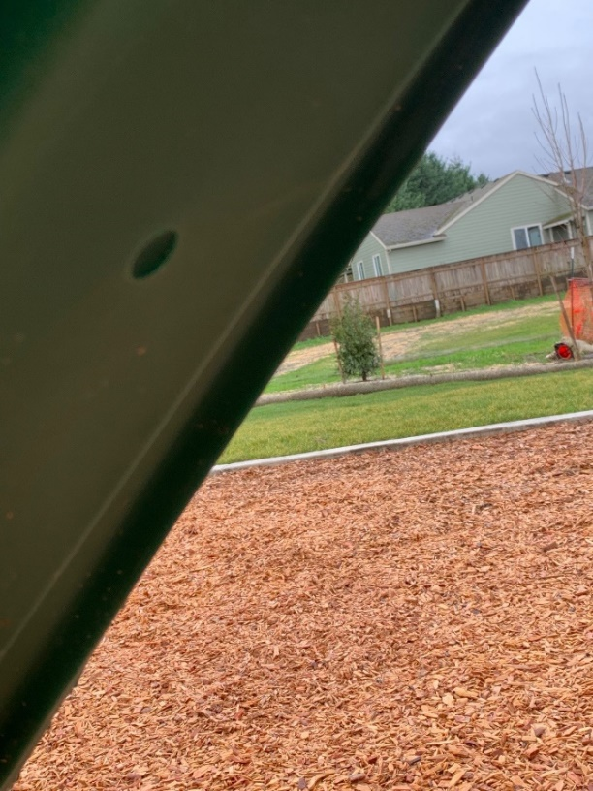

- Park Amenity Findings

  - Benches and bike racks through the park space that have been mounted in asphalt still wobble following developer tightening them.
  - The bollard at the western end of the park is missing. The two bollards closest to the bathrooms are locked up in one of the bathrooms. (see photo below)
